The Effect of Melatonin on the Rate of Amyloid-beta Aggregation in the
Caenorhabditis elegans Strain CL4176

Olivia Jeffers and Rathna Ramamurthi
Neuroscience Research Laboratory, Thomas Jefferson High School for Science and Technology

Amyloid-beta (A-β) aggregation is one of the suspected causes of the debilitating, neurodegenerative disease Alzheimer’s. Melatonin, a potent antioxidant and naturally-occurring neurohormone that regulates the sleep-wake cycle, is known to have an effect on A-β aggregation. The C. elegans strain CL4176 is genetically engineered to express the human A-β peptide and also to begin production at the time of a temperature upshift. We used the dye amyloid-specific dye NIAD-4 from Nomadics, Inc. to stain and image the CL4176 C. elegans. The data was ultimately inconclusive as, while researching, we confirmed a suspected difference between the C. elegans strain CL4176 and its sister strain CL2006. The CL4176 strain forms A-β peptides inside the cytoplasm, but forms no actual plaques. The CL2006, which was used in previous imaging experiments, actually forms a hydrophobic structure outside of the cells, which is more similar to AD A-β aggregation. For an unknown reason, the NIAD-4 dye only binds to the CL2006 A-β aggregations and not to the cytoplasmic A-β in the CL4176. If our experiment were to be continued, we would expose the C. elegans to a 0, 4, and 8 pM concentrations of melatonin, since 4 pM is the natural concentration of melatonin in average humans, and monitor the rate of A-β aggregation over time via staining and imaging.

Amyloid-beta (A-β) is commonly thought to be one of the primary causes of Alzheimer’s disease (AD) (Hardy and Allsop, 1991). Melatonin, a potent antioxidant and neurohormone, has long been suspected of having a positive effect on cognitive abilities of AD patients (Cardinali, et al., 2002). Not only have cognitive abilities been positively affected, but oxidative damage has been decreased as well (Reiter et al. 1998, Sharman et al 2002b). The Link lab has done extensive research on neurodegenerative disorders using C. elegans as a model (Link, C.D., 2006).

It was commonly accepted that the formation of A-β was the primary cause of AD symptoms (Hardy and Allsop, 1991), causing a cascade effect resulting the formation of more A-β plaques and neurofibrillary tangles and tau tangles. Recent data, however, have shown that in some cases tau tangles form before A-β aggregation (Schonheit et al., 2004) and even that there is a weak correlation between A-β aggregation and AD symptoms (Cummings et al., 1996).

As it has been postulated that melatonin only has an effect on A-β aggregation before accumulation begins (Quinn et al., 2005), then any type of treatment for AD would have to begin early on, before too many A-β plaques have formed. This could be up to decades before AD symptoms occur.

Whether or not A-β is the primary factor is unimportant, as there is a very strong correlation between A-β aggregation and neuronal death which causes many neurodegenerative diseases.

There is another aspect of AD that melatonin has potential effects on. Many Alzheimer’s patients suffer from insomnia and irregular sleep patterns. As melatonin is the primary hormone emitted at nighttime causing sleepiness, a lack of melatonin would cause insomnia. A lack of melatonin might also result in abnormal A-β aggregation. It is also known that melatonin concentrations in the body decrease with age (Lahiri et al., 2004), maybe causing the insomnia later in elderly AD patients. It is unknown if insomnia, caused by a lack of melatonin, causes A-β aggregation and AD later in life, or if the A-β aggregation damages the brain which causes a lack of melatonin excretion which causes the insomnia. Whichever it is, insomnia and AD are closely tied.

The purpose of our experiment was to see if melatonin decreased the rate of A-β aggregation in C. elegans strain CL4176. We chose the CL4176 strain of C. elegans, from the Caenorhabditis Genetics Center (CGC) at the University of Minnesota, as a model for A-β aggregation in humans. CL4176 expresses the human A-β peptide in the cytoplasm upon a temperature upshift from 15۫C .

As we were looking at the rate of A-β aggregation, it was best not to sacrifice the C. elegans in our research. The novel, A-β-specific dye NIAD-4 was introduced to us by Dr. Chris Link as a substitute for the less commercially available X-34. Using NIAD-4 allowed us to stain the C. elegans multiple times and thus drastically decreased the amount of time and trials involved in the experiment.

The C. elegans strain CL2006 was stained successfully with NIAD-4 by Dr. Maria Florez-McClure. The difference between the CL2006 and CL4176 is that the CL2006 begins A-β aggregation near birth and forms hydrophobic plaques of A-β which the NIAD-4 binds to, while the CL4176 begins A-β aggregation at a temperature upshift and only forms cytoplasmic A-β peptides which the NIAD-4 is unable to bind to. We did not know about the difference between cytoplasmic and extracellular plaques until the end of our experiment.

METHODOLOGY

Purchase of the C. elegans

A waiver for the CL4176 strain of C. elegans was granted by Dr. Anne Rougvie, Director of the Caenorhabditis Genetics Center (CGC) at the University of Minnesota. The wild type C. elegans came with the C. elegans Culture Kit from Carolina Biological.

The C. elegans were sent on starved plates and arrived as dauer larvae; larvae that have formed a hard shell of mucus for long-term storage in a starved environment. Once introduced to a food source they softened up and began reproducing.

There was initial debate on whether or not to use the C. elegans strain CL4176 (Fig. 7) or CL2006 (Fig. 8). According to WormBase, both strains expressed the human A-β peptide. The only difference was that the CL4176 began production upon a temperature upshift, while CL2006 began production near birth. The control of the time of aggregation was appealing to our experiment because of the focus on rate, so we chose the CL4176 strain.

What we found out later, after most of the experiment was completed, was that CL4176 create cytoplasmic A-β while CL2006 forms extracellular, hydrophobic clumps of A-β which is more similar to a plaque, and to which NIAD-4 binds. CL4176 does not have A-β formations that NIAD-4 can bind to.

Culturing E. coli strain OP50

The E. coli strain OP50 arrived with the same C. elegans Culture Kit from Carolina Biological and were stored at around 4˚ C in a refrigerator. There was one test tube of E. coli stock solution with 11 other test tubes full of E. coli growth solution.

For the purpose of aseptic technique, the mouths of the test tubes were flamed with a Bunsen burner. Using a serological pipette, 0.5 mL of stock E. coli were transferred into the other test tubes. The seeded tubes were then incubated at 37 degrees Celsius for approximately 24 hours, allowing for turbid growth, and were ready for use.

Putting Agar on the Plates

In order to create a habitat on which the C. elegans could be cultured, it was first necessary to fill the Petri dishes with a layer of agar. The agar arrived in glass bottles. We used the microwave to melt the agar. The agar was melted in the bottle with the cap loosened a quarter turn. It took approximately seven 30-second blasts for the agar to appear to be in a liquid state. Nearing the end of the melting, we were careful not to heat for too long or the agar would boil over the top of the bottle causing a mess.

Seeding E. coli

The openings of the E. coli tubes were flamed with a Bunsen burner and 1 mL of E. coli solution was extracted using a serological pipette. 0.5 mL of the E. coli solution were put onto each agar plate, allowing for as little contamination as possible, and then was spread with a sterile BactiSpreader, which was included in the Carolina Biological C. elegans Culture Kit.

Transferring C. elegans

A sterile scalpel was used to cut either a triangle or square from the agar. We were careful to choose a spot on the agar where there were the most C. elegans and that were the furthest away from the mold. The triangles or squares were about 1 cm in length on each side. The cut slices of agar were then placed face down, with the top of the old agar directly on the top of the new agar, on a new plate seeded with E. coli.

Getting Rid of Mold

As we suspected that mold fluoresced, we got rid of the mold by serially transferring the C. elegans until no more mold remained. The C. elegans were transferred and placed on the side of a fresh plate. As the C. elegans travel faster than the mold can grow, we transferred again about 5 to 24 hours later. The agar with the most C. elegans and least amount of mold were selected and retransferred. The process was repeated until no more mold remained, and the plates remained mold free for at least a week.

Experimental Design

The purpose of the experiment was to see if melatonin had any effect on the rate of A-β aggregation in the C. elegans strain CL4176. Our hypothesis was that introduction of melatonin would cause a decreased rate of A-β aggregation. The null hypothesis was that varying levels of melatonin would have no effect on the rate of A-β aggregation.

To test for various levels of melatonin exposure, we used three concentrations of melatonin in the E. coli food source mix: a control concentration of 0 pM, the natural concentration found in humans of 4 pM (Lahiri et al., 2004), and a high concentration of 8 pM. The 8 pM concentration was included to test for an upward trend in the concentration of melatonin and the decrease in the rate of A-β aggregation. With each level of melatonin concentration, a wild type strain of C. elegans was used as a control.

Table 1: An Individual Trial
 | 0 pM | 4 pM | 8 pM
CL4176 | 10 C. elegans | 10 C. elegans | 10 C. elegans
Wild Type | 10 C. elegans | 10 C. elegans | 10 C. elegans

We ran three trials, with 10 C. elegans in one strain-concentration group. Each C. elegans was imaged separately. Within each strain-concentration group, there was no need to maintain the individuality between the C. elegans since the data was averaged in the end.

The C. elegans were stained and imaged at an interval of once every 24 hours until death or paralysis.

The data was first represented as a direct picture image of what was seen underneath the fluorescent microscope. The pictures were mostly black, with a light fluorescence showing the outline of the C. elegans, combined with glowing spots of A-β aggregation.

Using the ImageJ software, a histogram was created with the number of pixels on the y-axis and brightness value of the red pixels on the x-axis. The A-β was represented as the brightest red pixels. The final data was given as the amount of A-β pixels per C. elegans. The data for each strain-concentration group was given as an average of A-β pixels per C. elegans.

The graphs showing the rate of A-β aggregation were made with the x-axis representing a time interval of 24 hours, and the y-axis representing the amount of A-β aggregation per strain-concentration group.

The rate of A-β aggregation was calculated by the slope of the linear regression line of the data. The rates of the three trials of each strain-concentration groups were averaged for a final rate of A-β aggregation.

Mixing Melatonin

Originally we used 200 proof ethanol as the solvent before realizing that the ethanol would be combined with the E. coli as a food source – a fatal combination. Melatonin is soluble in water, however, the experiment never progressed to the stage where the mathematics was worth considering. When creating the melatonin-water solution, the solution needs to be at 4 pM which is the natural amount of melatonin present in brain serum (Lahiri et al., 2004).

NIAD-4

The NIAD-4 was graciously donated by Randall Morse from Nomadics, Inc. We ordered 5.0 mg of the lyophilized powder (Order Number CN-01-B) and immediately stored it at -20˚C in a dark freezer until we were ready to mix the solution.

We used the NIAD-4 instead of other A-β specific dyes, like Congo Red or Thioflavin S, because it allowed us to stain the C. elegans multiple times without having to sacrifice the C. elegans. This allowed us to do our experiment much more quickly, with fewer C. elegans and with less cost to our laboratory. (See Table 2 for NIAD-4 Specifications and Fig. 1 for the molecular structure of NIAD-4)

Mixing NIAD-4

We used the histochemical/tissue staining method provided by Nomadics, Inc. which required a 10µM solution of NIAD-4 in 10% DMSO / 90% propylene glycol. In order to create this solution we did a series of dilutions:

Base Solution of 10% DMSO / 90% propylene glycol: 20 mL of DMSO were mixed with 180 mL of propylene glycol for a total of 200 mL of DMSO/propylene glycol solution.

First Dilution: 3.3 mg of NIAD-4 were added to 10 mL of the DMSO-propylene glycol solution.

Last Dilution: 101.34 µL of the First Dilution solution were transferred to 99.9 mL of the DMSO-propylene glycol base solution to create a 10µM solution of NIAD-4.
Between uses, the 10µM solution of NIAD-4 was stored at -20˚C in a dark refrigerator in a 250 mL Erlenmeyer flask, covered with parafilm.

Transferring Individual C. elegans

A sheet of Kimwipes was folded twice, creating a point, and dipped into water so that only the tip was wet. The tip of the Kimwipe was then gently touched to the target C. elegans so that the C. elegans would attach to the Kimwipe. Once perfected, this method took about one to two light prods to collect the C. elegans. An alternative method used an E. coli solution instead of water because it is believed that C. elegans can sense their food source and are more likely to attach to it. As we were short on E. coli, we used water instead.

The C. elegans were then transferred to a depressed microscope slide and stained. It is important to use a depressed microscope slide, as it is very easy to lose the C. elegans in the PBS rinsing process.

Staining and Rinsing in PBS

The NIAD-4 solution was warmed to room temperature before staining. Using a micropipette, about a drop of NIAD-4 solution was placed onto the C. elegans, which were then allowed to sit for 15 minutes.

The slide was then rinsed in four trays of PBS solution. It was very easy to lose the C. elegans in the rinsing process, so we were careful to rinse slowly and keep the tray parallel to the surface of the water.

As the PBS crystallizes very quickly, the excess PBS was dried off the slide and immediately observed underneath the fluorescent microscope. While the PBS crystals had no obvious effect on fluorescent imaging, it did obscure the natural light imaging.

Experiments with NIAD-4 Concentrations

As many particulates and molds were fluorescing and the CL4176 images looked identical to the wild type, we suspected that the concentration of NIAD-4 may have been too strong. We conducted a series of experiments with lower concentrations of the NIAD-4 solution.

There were three concentrations of NIAD-4: 10μM, 1 part DMSO-propylene glycol 1 part 10 μM NIAD-4, and 2 part DMSO-propylene glycol 1 part 10 μM NIAD-4. We imaged both CL4176 and CL2006 with the various concentrations to see if the mold and other particulates would stop fluorescing.

Analysis

Downloading ImageJ

ImageJ was downloaded for free from the Research Services Branch of the National Institute of Health Website. It is an image analysis program, very similar to Paint or Photoshop, but geared toward analyzing scientific images.

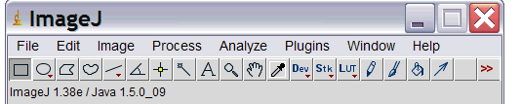
Figure 1. ImageJ Toolbar

We analyzed the images in the following way:

File
- Open
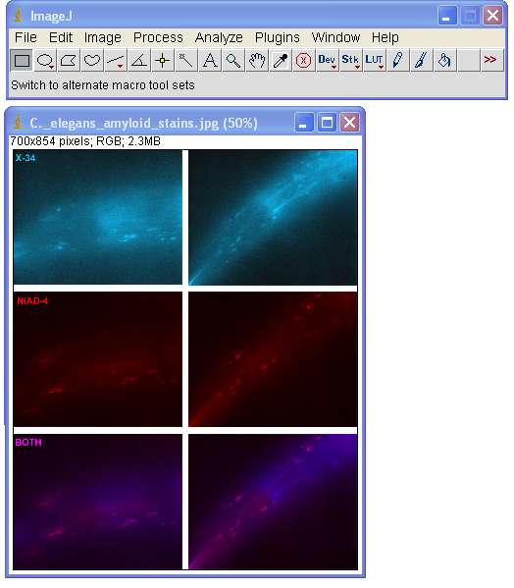
Figure 2. Original Image

The image was opened and the area was cropped (Ctrl+Shift+X). It is important to only select the C. elegans and only select the dark area, or else other fluorescence will be included and counted as A-β aggregation.
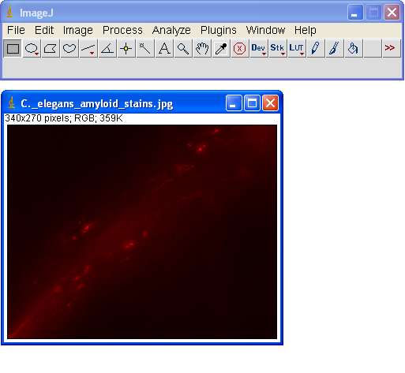
Figure 3. Cropped Image

The image was split into its red, green, and blue components.

Image
- Color
- RGB Split

The green and blue images were closed, leaving only the red image. This shows the image in black and white, allowing the user to select for brightness, which represents A-β aggregation.
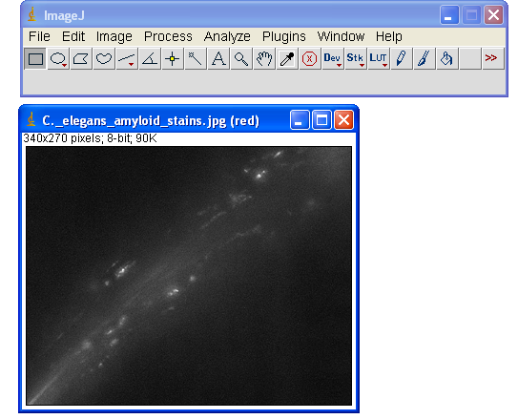
Figure 4. RGB Split Image - Red Selected

Image
- Adjust
- Threshold

The lower limit was set at 103 and the upper limit at the maximum of 255. In this manner, only the A-β plaques are red.
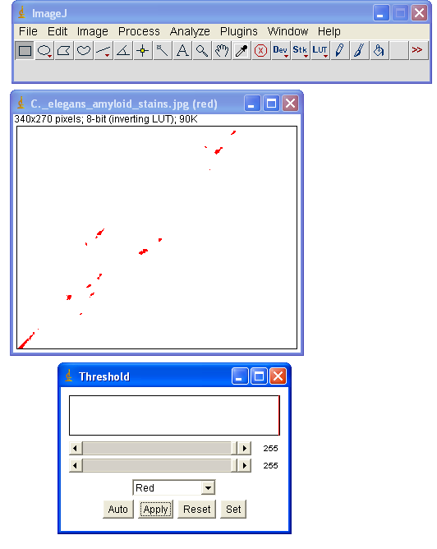
Figure 5. Threshold Adjusted Image

To get the number of pixels per C. elegans that represented A-β plaques we created a histogram.

Analyze
- Histogram

In this example there are 286 pixels at a value of 255. There are no other pixels at any values between 255 and 0 because of the previous imaging process. The pixels are all either at 0 or at 255.
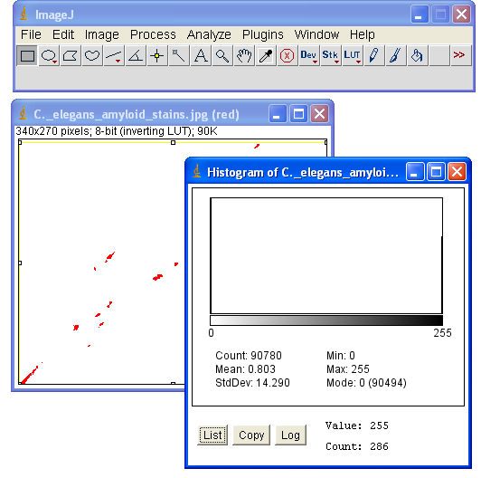
Figure 6. Final Analysis with Histogram

The numbers of pixels at value 255 represent A-β aggregation. The data for one group of strain-concentrations were an average of the pixels for the ten C. elegans members.

A linear regression of the average pixel values vs. time for each strain-concentration group was calculated and the slope was taken as the overall rate of A-β aggregation. These rates of A-β aggregation were used as comparisons between strain-concentration groups to determine whether or not the rate of A-β aggregation slowed depending on melatonin exposure.

Our experiment never reached the stage where considering statistical analysis was important. The data from the three trials would have been averaged with an error bound showing the accuracy of the data.

RESULTS

The stained images of the CL2006 sent by Dr. Chris Link and Dr. Maria McClure-Florez (Fig.10) were used as a sample image to compare to.

We imaged the CL4176 for A-β aggregation (Fig.11, 12), using the Wild Type as a control image (Fig.13, 15). If looked for, this image appeared to have a small bit A-β aggregation, however, ImageJ analysis showed that other particulates fluoresced brighter than the suspected spots of A-β plaques.

We later imaged an unknown C. elegans and received two glowing spots that appeared to be A-β aggregation (Fig25, 26, 27, 28). Later however, our images showed that many molds and particulates fluoresce.

In Fig. 19 and Fig. 21a mysterious rod shaped item, possibly a fiber or strain of mold, fluoresced very brightly. In Fig. 17and Fig. 18 a piece of mold fluoresced very brightly using a 10μM or less concentration of NIAD-4. We lowered the concentration to 1 part DMSO-propylene glycol and 1 part 10μM NIAD-4 to see if that would get rid of the background fluorescence. Fig. 14 and Fig. 16show a wildtype C. elegans with a spot of particulate to its upper left side. The particulate still fluoresces, but not as brightly as the C. elegans itself.

Another image of the CL4176 strain showed no A-β fluorescence and even, under fluorescence, showed particulates that could not be seen under the white light of the microscope (Fig. 29, 30). Fig. 29 was viewed after the staining process and was surrounded by NIAD-4 dye. Fig. 30 was taken after a rinse in PBS.

Most other images with a clear and distinct non-fluorescence (NF) image were taken before being stained with NIAD-4.

Another demonstration of the fluorescence of foreign objects is Fig. 23 and Fig. 24 where only a spot of mold is visible in Fig. 23, but upon fluorescence in Fig. 24, eggs and other particulates have a faint, outline fluorescence, while the piece of mold glows solidly. Fig. 20 and 22 also show many particulates not visible under white light.

Dr. McClure-Florez suspected that the NIAD-4 mixture used in the sample image was too high of a concentration, as the outline of the gut fluoresces faintly. However, using ImageJ analysis, it is clear of the difference between A-β plaques and the faint, outline fluorescence.

Fig. 25, 26, 27, and 28 were all taken of a C. elegans after a PBS rinse. The PBS formed crystals very quickly around the C. elegans, obscuring the view with the white light. Using fluorescence, however, the PBS crystals were not visible, and it looked as if there were two glowing spots of A-β aggregation. However, given that mold sticks to the bodies of C. elegans very often and fluoresces brightly, the images could not be counted as A-β aggregation.

DISCUSSION

The purpose of the experiment was to see if the consumption of melatonin had an effect on the rate of A-β aggregation.

The initial plan was to introduce C. elegans to various concentrations of melatonin and then to monitor the accumulation of A-β plaques over a period of time until death. The melatonin is both eaten with the E. coli and digested and is also thought to be absorbed through the skin (Tanaka et al., 2007).

While our experiment was not ultimately successful, we developed and discovered many techniques specific to our needs. We learned to use folded pieces of Kimwipes or any other filter paper, dipped in water, to select and transfer individual C. elegans. We also found it vital to use depressed slides when rinsing in PBS or else the C. elegans would be lost.

The experiment, however, was not successful in answering the question of the hypothesis.

We were unable to get a clear image of an A-β plaque, and thus unable to get any information on aggregation or rates. In addition to not being able to get any concrete data, we also found that many molds and other particulates fluoresced when stained with NIAD-4. We had one false positive of A-β aggregation (Fig. 25, 27), but upon discovering that mold fluoresces as well, and the C. elegans were covered in mold, we could not keep the image.

We still do not know if A-β fluoresces brighter than the mold, as if this were the case, then there would be no need to maintain aseptic technique. If mold and A-β plaques fluoresces about the same, or if mold fluoresces more, then aseptic technique is vital to the success of the experiment. This would mean that another method of transferring individual C. elegans is needed as the current one is not aseptic.

Upon consultation with Dr. Florez-McClure and nearing the end of our research time, we found that the lack of images could be caused by a suspected slight difference between the C. elegans strain CL2006 and CL4176 (see Fig. 7 and 8).

The difference that was already known was that CL2006 began accumulating A-β peptides from the beginning of life, while the CL4176 required a temperature upshift from 15۫۫C in order to begin expressing the A-β peptide.

We had initially planned to do the experiment with CL2006, which was used in successful imaging experiments with NIAD-4 by Dr. Florez-McClure. The CL4176, however, was a more attractive option as we could control the start times of accumulation and thus get more accurate data on rates.

As our experiment proved, however, NIAD-4 does not bind to the A-β peptides in CL4176 but does bind to the A-β peptides in CL2006. Dr. Florez-McClure hypothesized that this could be because CL2006 forms a hydrophobic structure of A-β plaques, which is what the NIAD-4 binds to, while CL4176 does not form a plaque, but rather has cytoplasmic A-β deposits, which the NIAD-4 does not bind to. It is not known what causes NIAD-4 to bind only to the CL2006 deposits and not the CL4176, which is a topic that requires further study.

Given that CL4176 was such a new strain, it did not come up in any of our preliminary research involving C. elegans strains and X-34 or NIAD-4 dye. The difference between the two was not explicitly stated in common English on the WormBase database where we ordered our C. elegans. There was information, on which genes specifically had been mutated, and those genes were different, but we just through the difference could be attributed to the required temperature upshift for A-β aggregation.

With the protocol we have laid out, the experiment can be continued with the C. elegans CL2006 strain. As the CL2006 may begin aggregating A-β at slightly (by a few hours) different times, this issue can easily be solved by just recording a base level of A-β aggregation and proceeding from there with regular calculations.

If we could get data on the effect of melatonin on A-β aggregation, the results could have many implications on the quality of life with people afflicted with Alzheimer’s or other neurodegenerative diseases caused by A-β plaques.

It has been hypothesized that A-β plaques begin forming decades before actual symptoms occur. If our hypothesis is proven, then people with a familial disposition to Alzheimer’s can begin taking melatonin earlier and possibly slow the rate of A-β aggregation, thus delaying the onset of Alzheimer’s symptoms. As melatonin is readily available in many convenience stores and pharmacies, and is commonly used as a treatment for jet lag, there should be no problem with distributing it to those who need it.

It is known that as age progresses, the amount of naturally-produced melatonin decreases (H Aguchi et al., 1982). Given that melatonin is one of the primary hormones causing sleepiness, a lack of melatonin would cause insomnia, which is also a common symptom of AD patients. Beyond replacing any lost melatonin and slowing the rate of A-β aggregation, an early regimen of melatonin treatments would also help anyone who has insomnia, induced by a lack of melatonin regulation in their circadian rhythm.

Further research could be done on whether or not melatonin can decrease the size of pre-existing A-β plaques. One study showed that melatonin only had an effect before A-β formed (Quinn et al., 2005). With slight variations to our experiment, the aforementioned experiment can be either confirmed or questioned.

There was also data implicating that an excess of melatonin actually decreases the life span (Bakaev et al., 1997) of C. elegans. The concentrations used were in the micromolar concentrations, which is a hundred thousand times more concentrated than what is naturally found in the body, which is around 4 picomolars. As melatonin production decreases naturally with age (Nair et al., 1986), a natural “young” concentration might be all that is needed to have a positive effect on the rate of A-β aggregation.

All of these experiments could help yield information leading to treatments that could help slow the progression of Alzheimer’s disease and give many people a few more years of life unmarked by the painful symptoms of Alzheimer’s.

CONCLUSION

The experiment did not yield data that supported or negated the hypothesis. Though the data did not support a conclusion about the effect of melatonin on A-ß accumulation in C. elegans, many other findings were made in the experiment. The discoveries we made relate to the experimental procedure that should be employed. We found that NIAD-4 imaging should not be performed on CL4176, but instead on the CL2006 strain. The A-ß in the CL4176 strain is cytoplasmic. It forms within cells, and therefore NIAD-4 does not bind to it. In CL2006, the A-ß aggregates outside of the cell in hydrophobic structures to which NIAD-4 binds. Further research is required to determine why NIAD-4 binds only to extra-cellular A-ß deposits.

We also discovered that mold fluoresces when stained with NIAD-4. Mold growth on the agar plates is common and harmless to the survival of the C. elegans. It only poses a problem when trying to differentiate in a fluorescent image between A-ß plaques and mold. We perfected a procedure for ridding the plates of mold to combat this problem.

Our findings can assist the continuing research on the effects of antioxidants on A-ß aggregation. Using the methodological improvements suggested, future researchers should attempt to carry out the experiment as we originally intended. NIAD-4 staining is a novel process that will prove very useful in A-ß imaging and research. The effects of antioxidants other than melatonin on A-ß aggregation would be interesting topics for further study as well.

REFERENCES

Bakaev VV, Efremov AV, Anisimov VN (1997). An attempt to slow aging in C. elegans. 8. Melatonin reduces life span of C. elegans. The Worm Breeder Gazette 15(1): 36.
Cardinali, D.P., Brusco, L.I., Liberczuk, C., and Furio, A.M., 2002. Neuro. Endocrinol. Lett. 23 Suppl 1:20-3.
Lahiri, D.K., Ge, Y.W., Sharman, E.H., and Bondy, S.C., 2004. Age-related changes in serum melatonin in mice: higher levels of combined melatonin and 6-hydroxymelatonin sulfate in the cerebral cortex than serum, heart, liver and kidney tissues. J. Pineal Res. 36:217-223.
Link, C.D., 2006. C. elegans models of age-associated neurodegenerative diseases: lessons from transgenic worm models of Alzheimer's disease. Exp. Gerontol. 41:1007-13.
Nair N.P.V., Hariharasubramanian N., Pilapil C., Isaac I., and Thavundayil J.X., 1986. Plasma melatonin: An index of brain aging in humans? Biol. Psychiatry 21:141-150.
Pappolla, M. A., Chyan, Y.-J., Poeggeler, B., Bozner, P., Ghiso, J., LeDoux, S. P., Wilson, G. L., 1999. Alzheimer β protein mediated oxidative damage of mitochondrial DNA: Prevention by melatonin. Journal of Pineal Research. 27(4):226-229.
Quinn, J., Kulhanek, D., Nowlin, J., Jones, R., Pratico, D., Rokach, J., and Stackman, R., 2005. Chronic melatonin therapy fails to alter amyloid burden or oxidative damage in Tg2576 mice: implications for clinical trials. Brain Res. 1037:209-213.
H Aguchi, K I Kato, and H Ibayashi, "Age-dependent reductions in serum melatonin concentrations in healthy human subjects." J Clin Endocrinol Metabolism 55: 27-29, 1982.

This is the proposed methodology, not what actually happened. Due to the differences between CL4176 and CL2006, we were never actually able to obtain an image and thus progress towards the analytical part of the experiment.
http://rsb.info.nih.gov/

